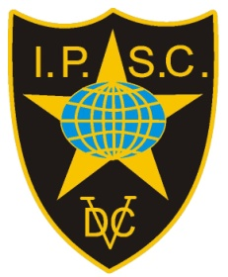

**Invitation**

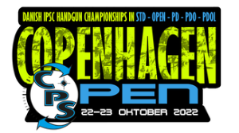

**Copenhagen Open 2022**

**Copenhagen**

**20th – 21st – 22nd – 23rd October 2022  
IPSC Denmark is happy to invite IPSC shooters from abroad to participate in our National Championships.**

**EU citizens with European Weapons Passport can enter w/o any gun registration.**

**Others pls. contact the organizers at markwise45@gmail.com**